Victoria-New South Wales Interconnector Congestion: Impact on Demand Predictability and Price Volatility in the NEM

Rumana, Vahora (n11777338)  
IFN695 Assessment 3

# Executive Summary

This report demonstrates how Victoria(VIC) and New Souh Wales(NSW) interconnector congestion affects demand predictability and price volatility in Australia’s National Electricity Market(NEM). Due to the rapid growth of renewable energy and growing electricity demand, this important connection between Victoria and New South Wales often operates near to its flow capacity. Congestion restricts the flow of electricity, resulting in price volatility and unpredictability in demand.

To better understand this issue, I examined various historical NEM datasets, comprising interconnector flow, dispatch region summaries, demand, and price data( datasets from AEMO: DISPATCHINTERCONNECTORRES, DISPATCHREGIONSUM, DEMANDOPERATIONALACTUAL, and DISPATCHPRICE). I defined congestion as periods when flow reached 95% of capacity and applied logistic regression to analyse the probability of congestion considering operational features(variables).

The analysis discovered that congestion generates pricing disparities between NSW and VIC and results in unpredictable demand variations, **particularly in NSW**. Predictive models obtained an **accuracy exceeding 80%** in detecting congestion events. These findings emphasize the operational importance of managing interconnector flow and indicate the significance of predictive analytics for grid planning and price stability in the NEM.

This report is also designed for non-expert readers interested in the challenges of energy infrastructure, emphasizing on how data-driven analysis can influence grid management decisions.

**Introduction**

The National Electricity Market (NEM) is essential for providing reliable electricity throughout Australia's interconnected areas. The VIC–NSW interconnector is a key transmission link, allowing significant electricity transfers across Victoria and New South Wales. However, this interconnector is under strain due to increasing demand for electricity and rapid integration of renewable energy sources such as solar and wind. This creates a recurring issue called interconnector congestion—a state in which electricity flow(measured in megawatts(MW))nears or reaches physical transmission thresholds which restricts the easy or smooth transfer of electricity.

Congestion has major operational consequences. It results in price instability (fluctuations of Regional Reference Price(RRP) - the official market price for electricity in each NEM region), interrupt energy flows, and lower the demand predictability. Knowing when and how these congested incidents affect market performance is essential for energy planners, system operators, and policymakers. This research examines the impact of congestion on the VIC–NSW interconnector on demand predictability and price volatility in the NEM. The analysis uses real-time operational datasets and predictive modelling to identify measurable trends in flow behavior, price dynamics, and demand fluctuations throughout congested and uncongested periods.

**Key terminology**, including congestion, RRP (Regional Reference Price), and MW flow, is defined and used consistently to describe these phenomena.

**Literature Review**

Interconnector congestion is a thoroughly documented phenomenon in worldwide electricity systems. In the context of National Electricity Market (NEM), previous studies have demonstrated that restricted interconnector capacity results in market inefficiencies and unpredictable regional pricing [1],[2].

The VIC–NSW interconnector is a highly studied and essential component of the National Electricity Market (NEM). As a part of the Eastern Interconnected System, this interconnector provides bidirectional electricity flow and aids regional balancing between Victoria's primarily brown coal and renewable energy supply and New South Wales' mixed fuel demand profile.

According to the Australian Energy Regulator (AER), congestion on interconnectors leads to regional price separation, distorting market efficiency and impacting both retail and wholesale pricing mechanisms[3]. This issue tends to occur during periods of peak solar output in Victoria which frequently leads in midday curtailment and reduced flow into New South Wales.

Previous research, including AEMO reports and Cornwall Insight analyses, shows the correlation between interconnector constraints and the increased frequency of undesirable pricing in one region alongside price spikes in another [4]. Figure 1 in this report—a time-of-day average of flow and export limitations over three years(2021-2023)—demonstrates that congestion is not random but structural, frequently occurring during midday when renewable energy generation is high.

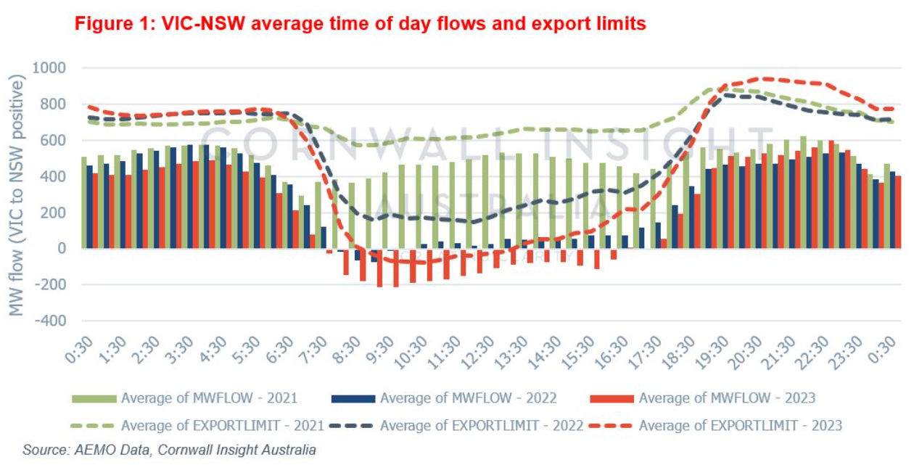

**Figure 1. VIC-NSW flow and export limits**

Methodologically, logistic regression has been employed in previous grid research for event classification [5]. In this report,  logistic regression is used to forecast congestion events built upon variables such as flow, limits, and demand. Moreover, predictive modelling in the electricity sector has been progressively used to detect system stress and reliability vulnerabilities. Studies using logistic regression and machine learning classifiers has demonstrated efficiency in identifying congestion patterns based on factors such as export limits, demand spikes, and RRP spread [6], [7]. These methods enable system operators to implement preventive measures, improve forecasting accuracy, and enhance dispatch planning.

Recent research shows the significance of merging operational datasets like demand profiles and dispatch summaries to obtain a comprehensive understanding of congestion effects. This methodology aligns with recent practices in smart grid analytics, wherein predictive modelling is utilised not just for detection but also for anticipating grid management [8].

These findings reinforce the necessity for improved demand-side and congestion analytics.

To summarize, existing literature confirms that –

* Congestion is recurring and structural, rather than occasional.
* It causes volatility in RRP, particularly in importing regions such as NSW.
* It lowers demand predictability, as congestion disrupts normal load patterns.
* Predictive analytics can efficiently identify or predict congestion events when combined with dispatch data, aiding both planning and real-time operations.

This research builds on these foundations through the combination of a congestion detection algorithm with multi-variable visualisation and a predictive model, thereby contributing to more thorough understanding of interconnector congestion in practice. Additionally, it base supports the objectives of this analysis: to determine when, how and why of congestion and to fully understand its consequences for regional electricity dynamics-especially between Victoria and New South Wales.

**Approach**

I built a systematic methodology that combines data collection, congestion event detection, exploratory visualization, and predictive modelling to understand the effect of VIC–NSW interconnector congestion. The following steps describe the process thoroughly:

1. Data Collection and Sources: Four important operational datasets were collected from the Australian Energy Market Operator (AEMO) that cover various aspects of the energy market-
2. DISPATCHINTERCONNECTORRES: Provides 5-minute electricity flow data for interconnectors, containing actual flow (MW), target flow, and limits.
3. DISPATCHREGIONSUM: Records regional dispatch information, including demand and generation measures for Victoria and New South Wales.
4. DEMANDOPERATIONALACTUAL: Provides actual operational demand data over time.
5. DISPATCHPRICE: Contains Regional Reference Price (RRP) data for both Victoria and New South Wales.

These datasets are from August 2024 - January 2025(6 months), providing a recent and detailed time window for analysis.

1. Data Preprocessing: The datasets were combined using SETTLEMENTDATE as their common key. To ensure consistency, time zones and formats were standardized. Numeric columns with missing values were handled by mean imputation, whilst string-based nulls were substituted with "Unknown" in order to maintain data integrity. Irrelevant columns & metadata were removed. Datetime formats have been converted with pd.to_datetime. Duplicates were removed, and the datasets were filtered to include records just from the VIC1 and NSW1 regions.

Subsequently, I developed several new features:

1. Congestion Flag: A binary flag was established to identify congestion. If the actual flow was around 95% of the export limit (regardless positive or negative), the time step was classified as congested.
2. Hour of Day and Is Weekend: Time-based indicators were added to identify cyclical or weekly congestion trends.
3. Additional lag features such as CONGESTED_LAG1 were created to analyse post-congestion effects on price(during price analysis).
4. Exploratory Data Analysis: Exploratory Data Analysis was conducted to analyse congestion patterns and their correlation with demand and price. I calculated:
5. Demand patterns in New South Wales during periods of congestion vs non-congestion.
6. Average hourly flows to determine periods that experience congestion.
7. Variations in the Regional Reference Price (RRP) between New South Wales and Victoria during periods of congestion to measure pricing disparity.
8. Utilised lagged congestion features to study delayed pricing effects.
9. Congestion Classification: I used logical conditions to identify congestion based on flow in relation to export/import limits. This binary classification enabled downstream use within statistical and predictive models.
10. Comparative Visualisation : I made time-series graphs that shows the key dynamics of the VIC–NSW interconnector. These graphs featured overlays of actual electricity flows compared to export and import constraints to determine congestion thresholds. Furthermore, I generated comparative demand curves for both congested and non-congested periods, demonstrating the shifts in demand behaviour under different grid conditions. Lastly, I analysed the NSW and VIC Regional Reference Prices (RRPs), emphasising congestion windows with vertical shaded bars to indicate periods of price separation. These visualisations were essential in revealing structural congestion patterns and supporting the results of the predictive analysis. Each graph was closely labelled and annotated to convey meaningful insights. For instance, shading was used to indicate congestion windows, dashed lines represented flow limits, and coloured trends demonstrated regional disparities. These visualisations made the data understandable for both technical and non-technical audiences. The use of both libraries provided flexibility: Plotly facilitated interactive and presentation-friendly visuals, while Matplotlib allowed for precise control over formatting, font size, and layout during the generation of static figures for the report.
11. Predictive Modelling: I developed a logistic regression model to forecast congestion events. The variables contained demand, weekend flags, hour of day, actual flow, and export constraints. The model was assessed using a confusion matrix and criteria such as precision and recall, obtaining classification performance over 80%. This confirms the feasibility of predicting congestion based on operational features.

# Findings

1. **Exploratory Data Analysis (EDA)**

To provide empirical grounding for the research question—how VIC–NSW interconnector congestion affects demand predictability and price volatility in the NEM—an exploratory analysis was conducted using visual and statistical techniques. This analysis supports insights from prior studies (AEMO, Cornwall Insight) and informs subsequent modelling.

1. Hourly Average Flow and Limits

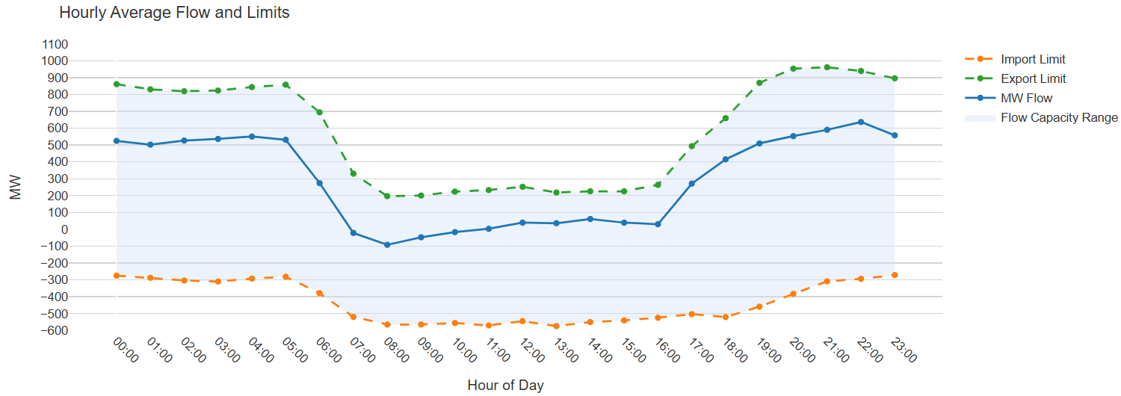

**Figure 2. Hourly Average Flow and Limits**

This graph shows the hourly average electricity flow (solid blue line) across the VIC–NSW interconnector alongside its export (green dashed) and import (orange dashed) limits. The shaded region represents the allowed capacity range. While flow remains stable during early morning and evening hours, a sharp decline is observed between 06:00 and 16:00, nearing or even breaching the lower limit, particularly around midday. This contrasts with earlier patterns reported by AEMO and Cornwall Insight which shows that during 2021-20223 the midday congestion is attributed to rising exports driven by solar oversupply.

In this dataset, the drop suggests proactive flow management or capacity restrictions, reinforcing that congestion is structural and time-dependent. Both highlight that the VIC–NSW interconnector experiences its most constrained flow conditions around midday—regardless of whether it's due to physical flow drops (the above graph) or tightening export limits (AEMO’s graph) and point to midday as a high-risk window, justifying the need for hour-aware congestion forecasting and its downstream impact analysis.

1. Sample Operational Demand – NSW vs VIC (First 2 Days)

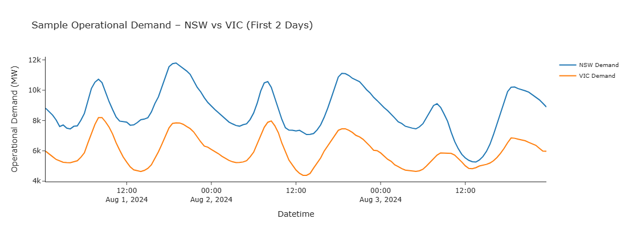

**Figure 3. Sample Operational Demand – NSW vs VIC (First 2 Days)**

This line graph compares short-term operational demand between New South Wales(blue line) and Victoria(orange line) over a two-day window starting August 1, 2024. The X-axis indicates time, while the Y-axis shows demand in megawatts(MW).

The graph reveals a clear cyclical demand pattern, with NSW consistently demonstrating higher demand levels and sharper peaks compared to VIC. The demand curve for VIC appears somewhat stable, while NSW shows noticeable fluctuation—suggesting its greater sensitivity to grid conditions, including potential congestion impacts.

This comparison is essential as it visually supports the assumption that NSW, being more demand-intensive, is likely more vulnerable to disruptions when the VIC–NSW interconnector becomes constrained. The pattern justifies the report’s focus on NSW demand predictability as a key analytical dimension and sets the stage for evaluating how congestion events distort regional load curves.

1. MW Flow on VIC1–NSW1 Interconnector Over Time

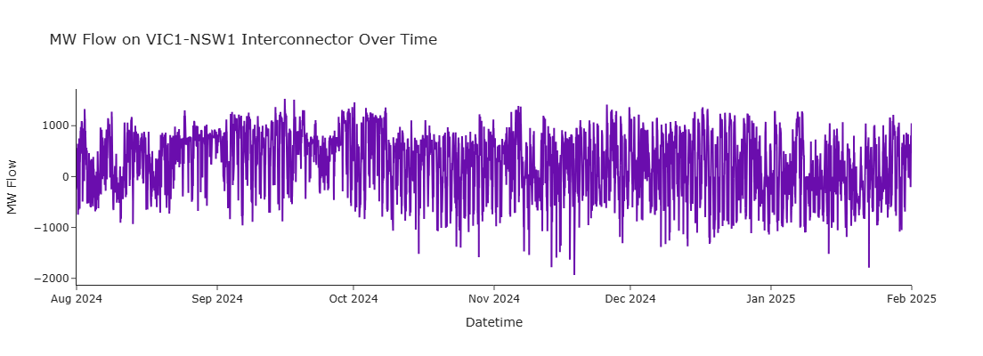

**Figure 4. MW Flow on VIC1–NSW1 Interconnector Over Time**

This graph illustrates the actual electricity flow (in MW) across the VIC1–NSW1 interconnector between August 2024 and January 2025. The Y-axis indicates the flow magnitude in megawatts (MW), while the X-axis represents time. Positive values denote electricity flowing from Victoria to New South Wales, and negative values indicate the reverse direction.

The visual highlights how the interconnector frequently operates near its upper and lower flow bounds, with sustained peaks and troughs over time. This persistent pattern suggests not just episodic stress but recurring structural congestion. The visual supports the operational definition of congestion used in this study (≥95% of export/import limit) and validates the congestion flag established during preprocessing.

This temporal congestion pattern justifies the next stage of analysis—examining how such flow stress affects demand behaviour and market pricing.

1. **Congestion Detection and Pattern Analysis**
2. Energy/Electricity Flow Direction

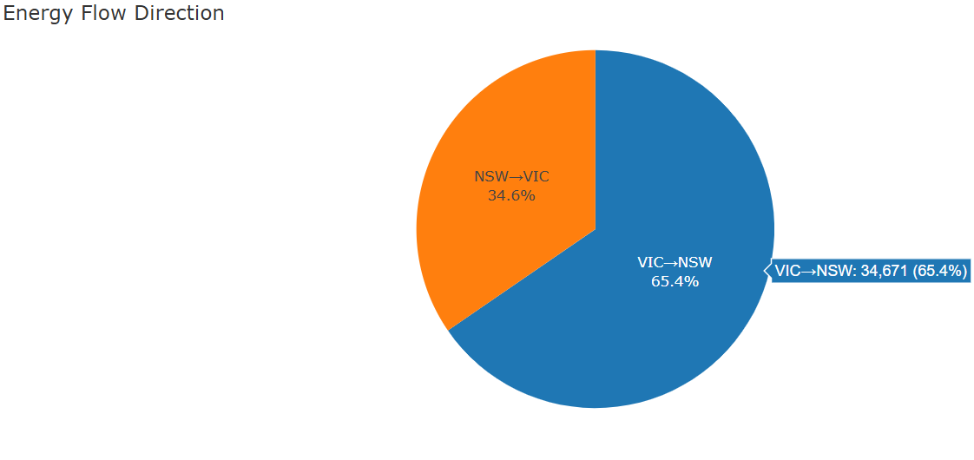

**Figure 5. Electricity Flow Direction**

The pie chart depicts the directional flow of electricity between Victoria and New South Wales from August 2024 and January 2025.

It demonstrates that 65.4% of electricity transferred from Victoria to New South Wales, indicating that VIC is a major source of supply for NSW. This supports the rationale for using the VIC–NSW interconnector as the study's focal point and aligns with previous observations.   
It prepares the ground for assessing the effects of any disruptions along this path on pricing and demand downstream.

1. Total Demand in NSW during congested and non-congested periods

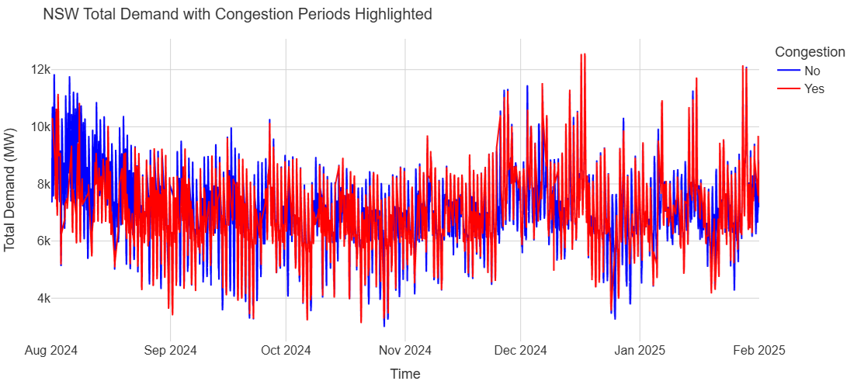

**Figure 6. NSW Total Demand with Congestion Periods Highlighted**

As observed in the pie chart earlier, more than 65% of New South Wales' electricity comes from Victoria which highlights the state's reliance on VIC-to-NSW interconnector flow. We now assess NSW's demand behaviour to get a better understanding of how this demand influences the risk of interconnector congestion. The NSW demand over time can be seen in this line graph during congested (red) and non-congested (blue) periods. Notice how red lines which represents congestion shows sharper and more erratic spikes. This implies that demand is less predictable and that congestion usually happens during periods of high demand. Demand behaviour becomes uncertain due to congestion. It demonstrates how grid stability is disrupted by congestion, which restricts flow and validates the necessity for proactive forecasting systems.

1. Demand During Entire Week

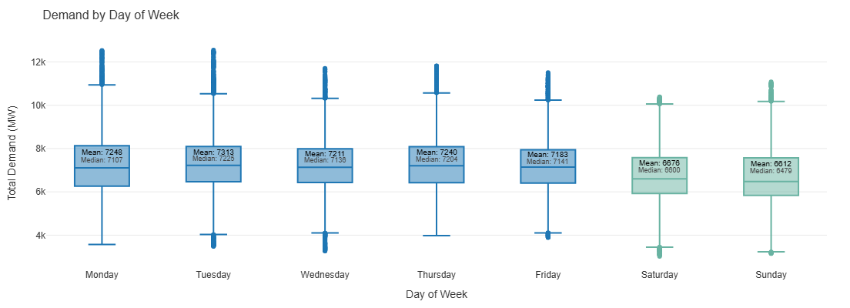

**Figure 7. Demand by Day of Week**

We now analyse NSW’s demand behavior throughout the week to discover any cyclical patterns that may influence or coincide with congestion. By analysing NSW's overall demand by day of the week, this boxplot expands on the flow-dependence observations.The distribution range, median, and mean demand for that day are shown in each box. Weekends are displayed in green, and weekdays in blue. It demonstrates that the mean demand is consistently higher on weekdays than on weekends—for example, Tuesdays average 7313 MW whereas Sundays average 6612 MW. This suggests more intense and sustained load conditions during weekdays, most likely because of industrial and commercial activities. This directional dependence can be partially explained by NSW's higher weekday demand, which confirms that the state imports more energy during its high-load hours, which are mostly during workdays. It lays the groundwork for later sections that analyse whether congestion is more prevalent during certain hours(when), and whether this variation contributes to the instability and unpredictability observed in earlier demand and flow visualisations.

d. Congestion and Non-Congestion Rates per hour

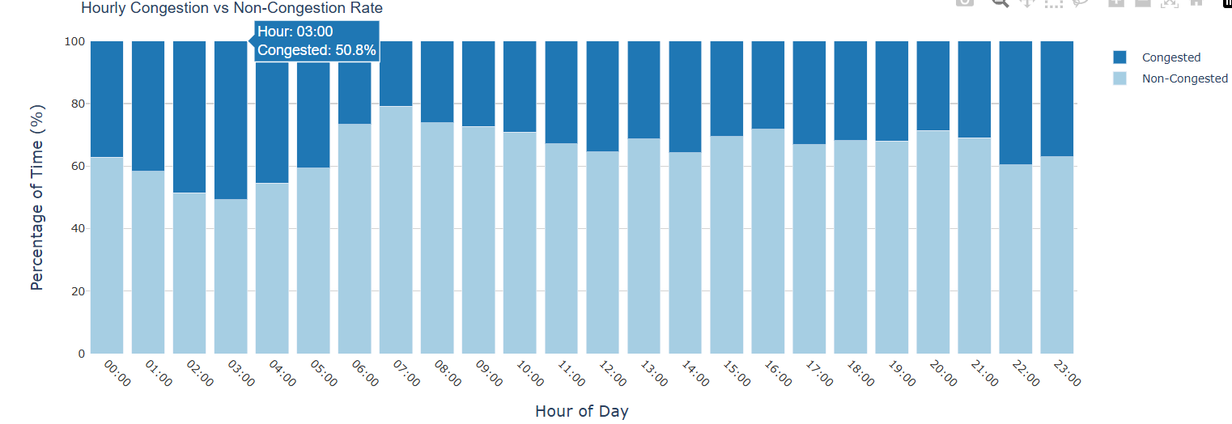

**Figure 8. Hourly Congestion vs Non-Congestion Rate**

This stacked bar chart shows the percentage of time Victoria–New South Wales interconnector was congested at each hour of the day. The input data covers both VIC and NSW, but congestion status represents interconnector-level stress based on flow thresholds.

This chart shows that congestion happens most frequently during 00:00 to 06:00, peaking at 03:00 am with a probability of over 50% congestion. The rate of congestion decreases and stabilises over the day. This irregular pattern shows that congestion is not solely reactive to demand but structurally influenced by interconnector constraints. These results strengthen the case for including time-of-day features in predictive models in order to control flow uncertainty during off-peak hours.

1. Variability in Demand during congested vs non-congested periods

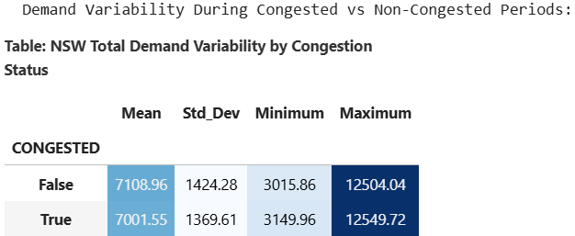

**Figure 9. NSW Total Demand Variability by Congestion**

The table quantitatively(statistical demand measurement) compares overall electricity demand in NSW during congested and non-congested periods. The slightly higher standard deviation(Std_Dev) during non-congestion (1424.28 MW vs. 1369.61 MW) indicates that congestion flattens but does not eliminate variability, even though the mean remains same under both conditions (~7100 MW). This suggest that demand is still quite erratic even amid congestion.

1. Daily Congestion Frequency

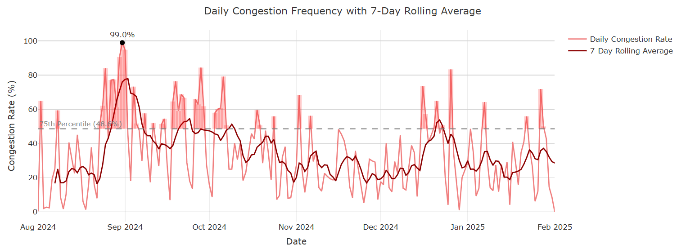

**Figure 10. Daily Congestion Frequency with 7-Day Rolling Average**

Note: The 7-day rolling average requires data up to January 31 to finish its final window, which is why it has been slightly extended into February. It does not contain February data.

The above line graph displays the VIC-NSW interconnector's daily congestion rates from August 2024 to ending of January 2025. Short-term fluctuations are smoothed out by a 7-day rolling average (dark red line). The Y-axis shows percentage of time congestion happened on each day.

The most notable finding is the 99% peak congestion in early September 2024, when almost the whole day experienced constrained flow. The rolling average during this time continuously exceeds the 75th percentile (≈49%), suggesting a congestion-prone period probably due to spring’s strong solar output and restricted export flexibility, as indicated by earlier literature. Although daily congestion fluctuates post September, the rolling average never fully stabilizes, suggesting continuous structural congestion risks instead of isolated occurrences. This unstable behavior strongly supports the core argument that congestion has seasonal and operational patterns and it’s not random.

1. Duration of Congestion Events

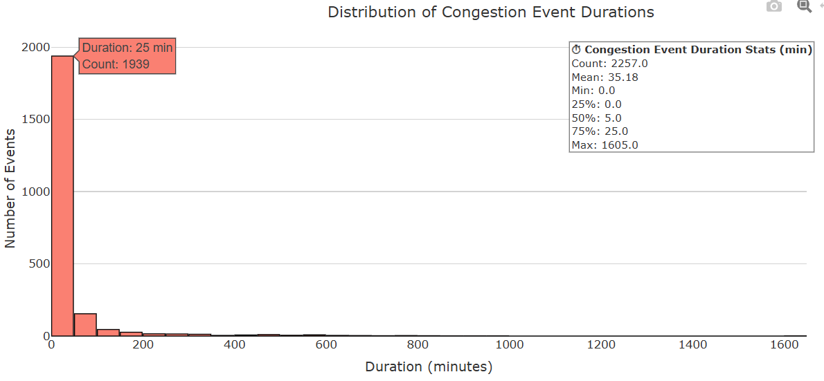

**Figure 11. Distribution of Congestion Event Durations**

The histogram shows the distribution of congestion event durations(in minutes) over the VIC–NSW interconnector from August 2024 to January 2025. The X-axis displays duration of each congestion event, whereas the Y-axis represents the number of such events that took place during that duration range. The strong jump in the first bar indicates the majority of congestion occurrences are short-lived, with over 85% lasting 25 minutes or less. Even though there are a few uncommon outliers that last longer than 1600 minutes, the median time is only 5 minutes, and 75% of all occurrences are under 25 minutes. This suggests that congestion is typically frequent but short-lived rather than being sustained and prolonged,  while these short occurrences might appear minor individually, the high frequency of these events - 2257 in total contributes significantly to the overall instability of the grid.

Price Analysis

**Why Price Analysis Is Needed?**

The National Electricity Market(NEM) functions on Regional Reference Pricing (RRP), which can diverge significantly when transmission is constrained. Given that more than 65% of NSW's electricity is imported from VIC (verified by our above analysis), it is critical for both market efficiency and operational planning to comprehend how congestion affects price fluctuations, particularly for importing regions like NSW.

1. 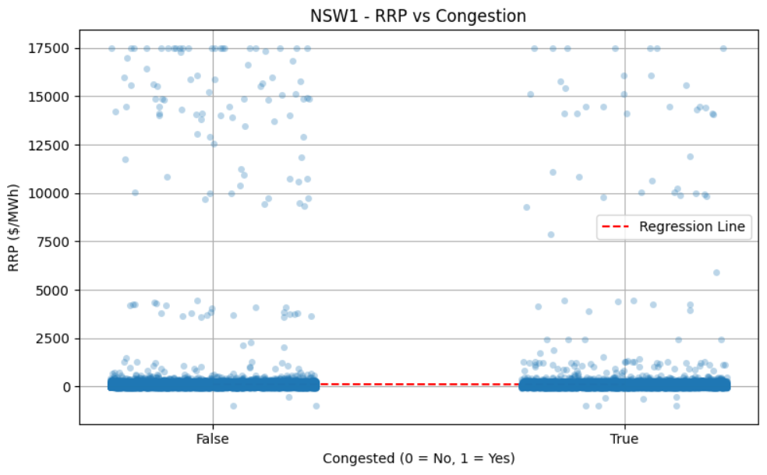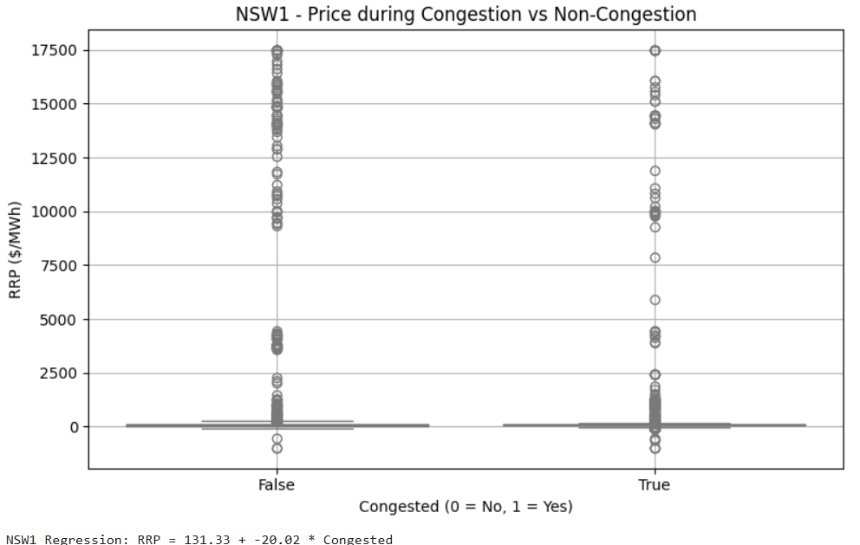NSW RRP During Congestion vs Non-Congestion

**Figure 12. NSW1 – Price During Congestion vs Non-Congestion and NSW1 – RRP vs Congestion**

This graphs here(NSW) and below (VIC) shows **absolute prices** within each state during congestion.

The above graph contradicts the common belief that congestion always drives prices upward. It compares NSW Regional Reference Price (RRP) during  both congested and non-congested scenarios. Surprisingly, the average RRP during congestion seems to be somewhat lower than during uncongested periods, although they both exhibits significant price spikes. Congestion in NSW creates unpredictability rather than constantly raising prices. This highlights that congestion not only cause upward pressure but also causes instability which complicates forecasting and dispatching strategies for market operators. The regression result : RRP = 131.33 – 20.02 * Congested confirms this finding, indicating that prices tend to drop by approximately $20/MWh during congestion.  
This outcome may seem counterintuitive at first. However, it implies that congestion can suppress prices in importing regions such as NSW - possibly as a result of automatic curtailments, demand-side responses, or market caps triggered  by system limitations. This finding is supported by the regression line, which indicates a slight inverse relationship between price and congestion.

1. VIC RRP During Congestion vs Non-Congestion

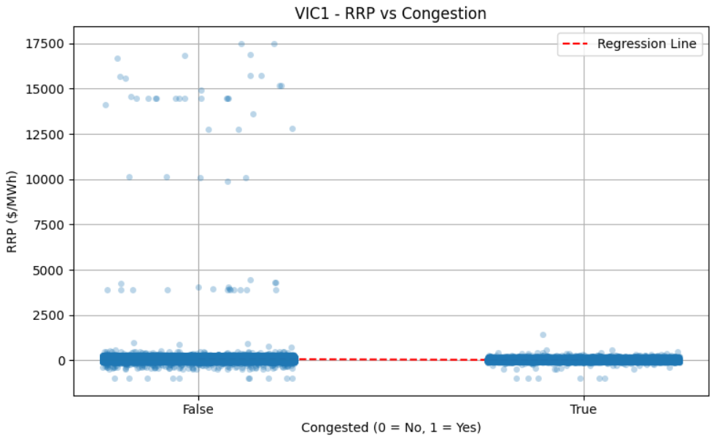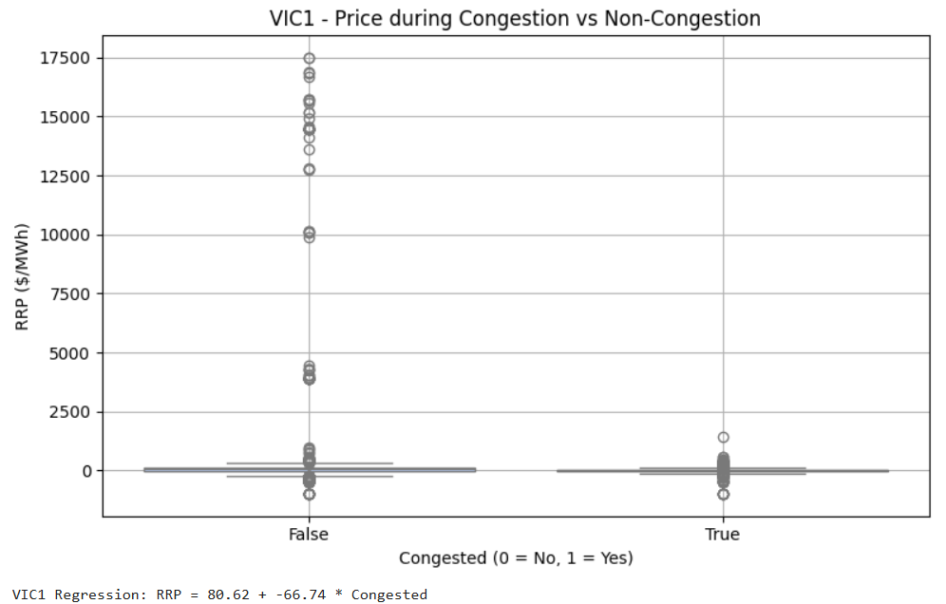

**Figure 13. VIC1 – Price During Congestion vs Non-Congestion and VIC1 – RRP vs Congestion**

Victoria acts more like a classic exporting region than New South Wales. This graph demonstrates that VIC's RRP(absolute prices) is substantially lower during congested times than it is during non-congested. The regression result: RRP = 80.62-66.74 * Congested confirms that prices in VIC tend to drop sharply around $67/MWh during congestion. This happens because electricity cannot flow out to NSW due to the congestion events which causes local oversupply within VIC and price suppression. Price coupling between states is reduced by congestion. NSW experiences volatility or artificial flattening during congestion, while VIC faces price drops. This demonstrates how congestion not only affects supply flow but also undermines market efficiency by affecting regional price uniformity. The regression analysis confirms a significant negative relationship between congestion and RRP in VIC. This finding is in line with the economic logic of bottlenecks: when exports are restricted, excess supply accumulates locally and drives down prices.

1. Operational Demand vs Price(RRP)

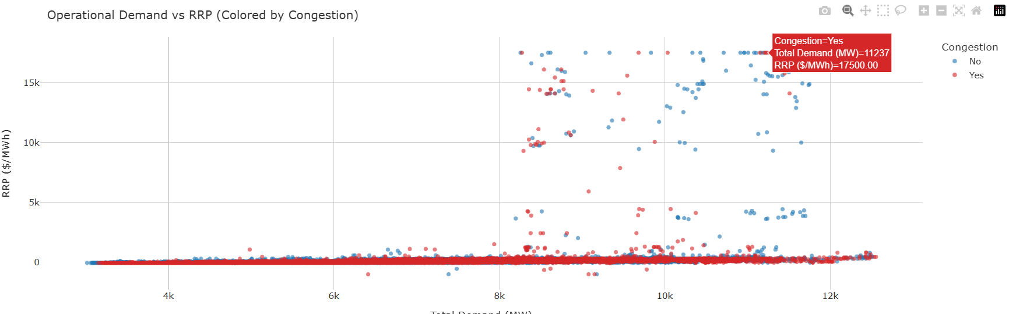

**Figure 14. Operational Demand vs RRP**

This scatter plot illustrates the relationship between the price of electricity (RRP) and total demand in both congested (red) and non-congested (blue) circumstances. We can observe that prices are more broadly spread and reach higher peaks under congestion (red dots), particularly when demand exceeds nearly 8000 MW. A notable example from the plot displays an RRP of $17,500/MWh and a demand of 11237 MW. On the other hand, high demand rarely results into such sharp price increases during uncongested periods (blue dots). This implies that congestion increases the impact of strong demand on prices, resulting in volatility. This is a key insight: congestion doesn't just restrict flow of electricity but it also makes prices more sensitive to demand.

1. Inter-Regional RRP Spread Vs Congestion

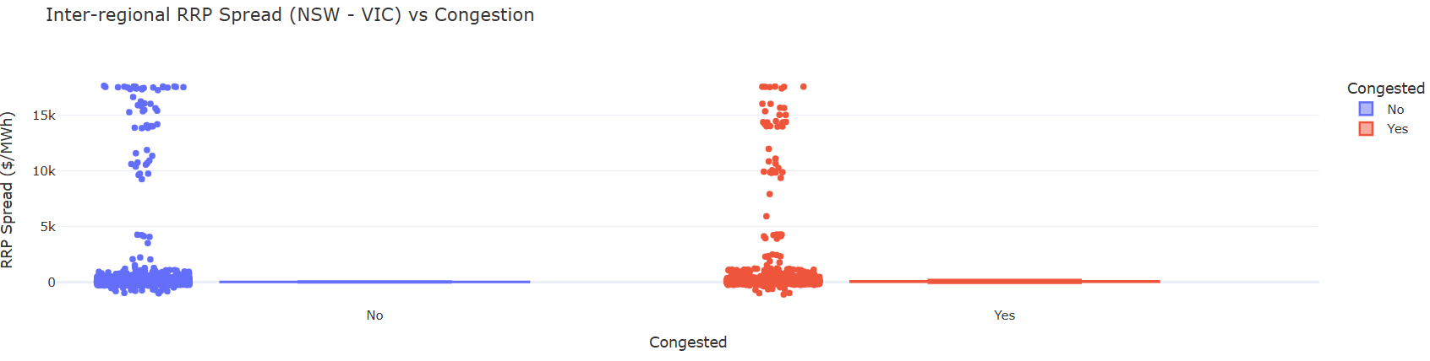

**Figure 15. Inter-Regional RRP Spread(NSW-VIC) Vs Congestion**

The RRP spread between VIC and NSW increases significantly during congestion, despite the fact that average NSW prices may not necessarily rise because of market caps or dispatch changes. This highlights the underlying volatility/instability and market decoupling effects caused by interconnector constraints. Spreads are more uniform and smaller when there is no congestion. During congestion they can reach $17,000/MWh. This validates the hypothesis that congestion skews pricing signals and leads to regional imbalance.

1. Average RRP Spread (NSW-VIC)

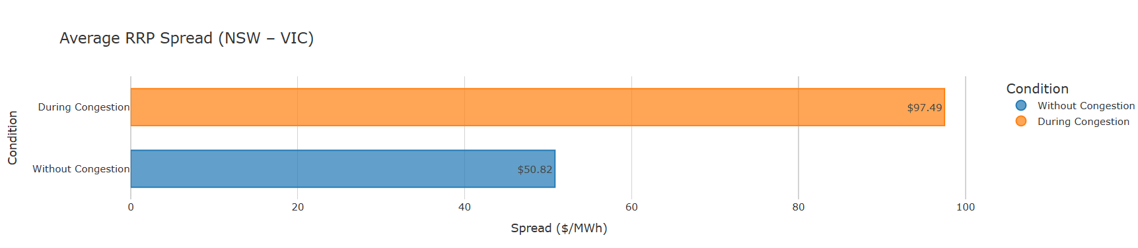

**Figure 16. Average RRP Spread (NSW-VIC)**

This horizontal bar graph shows average RRP difference(spread) between VIC and NSW i.e. how far apart they are during congestion compare to normal periods. That margin almost doubles during congestion, going from roughly $50.82 to $97.49 per MWh. That's a 92% increase, which is a specific statistical measure of how price symmetry gets disrupted by congestion. This is because VIC experiences price suppression caused by local oversupply, whilst NSW persists less price drop because of import dependence. So even if VIC and NSW prices both slightly decline during congestion, the difference(gap/spread) between them can still widens, particularly if VIC prices decline more sharply than NSW's ( as we saw in their individual charts (regression graph for NSW & VIC individual)). This discrepancy triggers market decoupling - a key sign of interconnector stress.

1. Lagged RRP Response

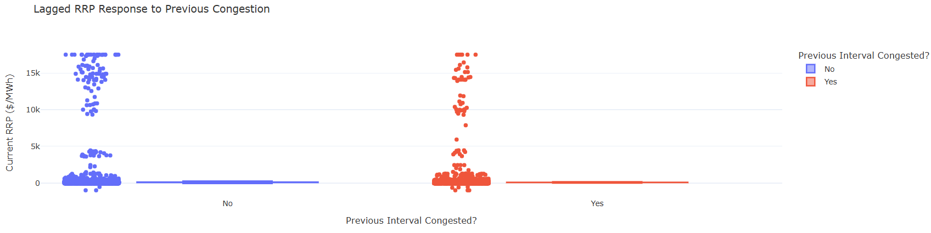

**Figure 17. Lagged RRP Response to Previous Congestion**

This plot investigates if past congestion has an impact on current prices in order to investigate temporal effects. The results shows a subtle increase in RRP even when congestion has cleared, suggesting that congestion leaves a persistent price shadow. This has planning consequences because operators cannot anticipate pricing stability immediately after flow recovery.

1. Price(RRP) in NSW during congestion

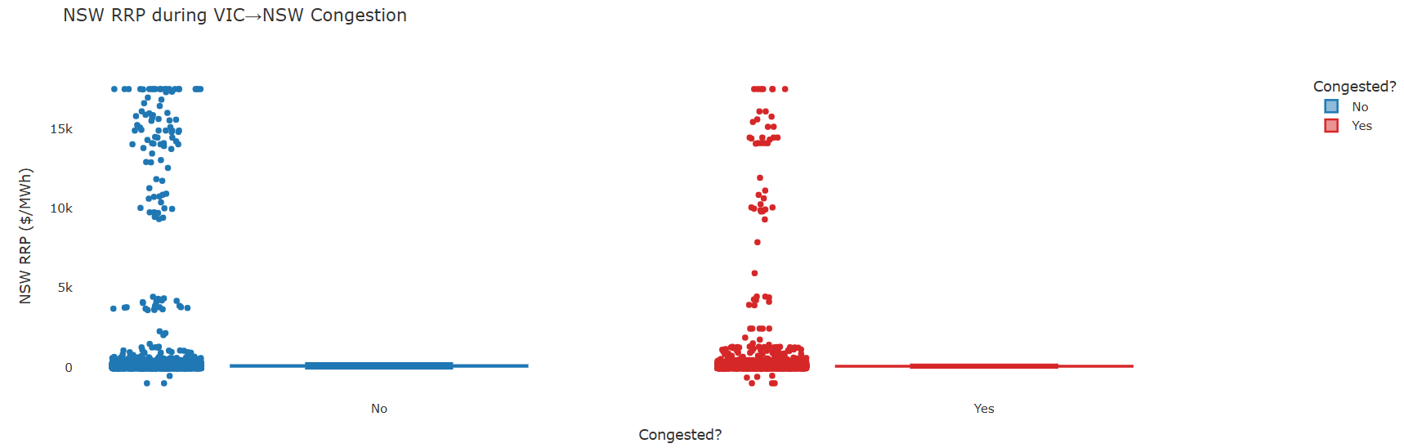

**Figure 18. NSW RRP during VIC-NSW Congestion**

This graph illustrates how congestion from the VIC–NSW interconnector directly impacts NSW by concentrating solely on prices in the state. Even though the congestion occurs on interconnector, the price changes are more noticeable in NSW because it depends on electricity from Victoria.  This graph confirms that high prices still occur during congestion, although their distribution becomes more volatile. The distribution of data points during congestion (shown in red) shows extreme volatility, with prices reaching as high as $17,000/MWh, even though the average price may not rise significantly. The congestion periods display a tighter but still severe range than the more scattered non-congested values (blue), suggesting instability rather than steady rise.

1. Electricity Flow, Congestion, and VIC-NSW Price Combined

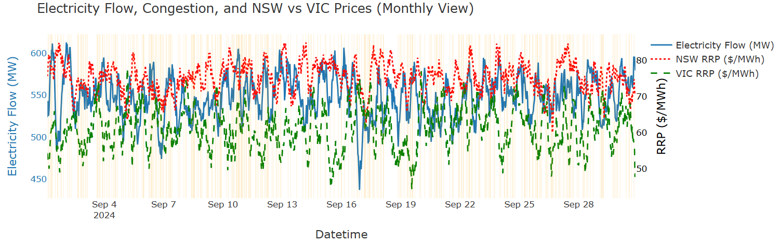

**Figure 20. Electricity Flow, Congestion, and NSW + VIC Prices (Monthly View)**

The above graph combines the previous two individual graphs i.e. Electricity Flow, Congestion and Pricing for NSW and VIC to provide a comprehensive view in a single visual. This graph compares electricity flow(blue), the VIC price (green dashed), and NSW price (red dashed) during September 2024. Yellow backgrounds indicate times of congestion. The key takeaway is the clear difference in VIC and NSW prices during congestion. NSW prices frequently increase while VIC prices stay comparatively stable, demonstrating how congestion leads to price decoupling across states. The flow line primarily stays within a small range, however slight fluctuations can increase price volatility in NSW when combined with congestion. This graph supports the claim that interconnector congestion affects the importing state (NSW) the most and disrupts regional pricing alignment in addition to restricting flow.

1. **Logistic Regression Model(Predictive Model)**

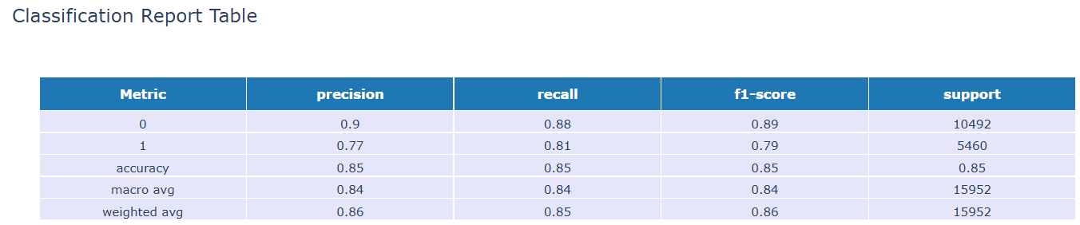

**Figure 21. Classification Report**

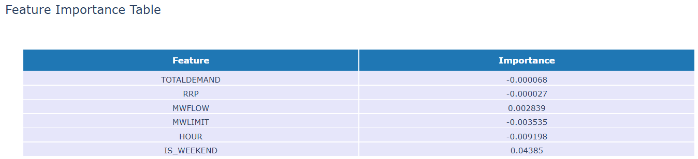

**Figure 22. Feature Importance**

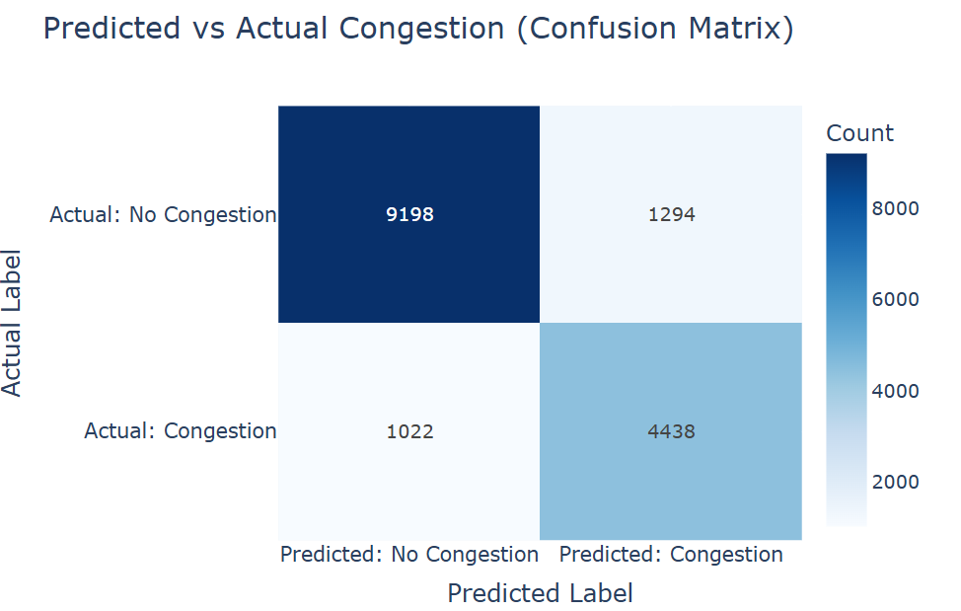

**Figure 23. Confusion Matrix of Predicted vs Actual Congestion**

****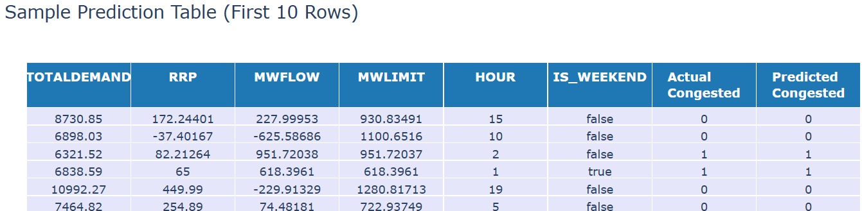

**Figure 24. Sample Prediction**

This section introduces a predictive framework that uses operational and temporal features to predict congestion events after a detailed exploration of the effects of congestion on interconnector flow, pricing, and demand. The main objective for this is to enabling proactive grid management and reducing price and stability risks through timely  interventions. A logistic regression model was designed to classify if there will be congestion at a specific 5-minute interval. The model was trained on main predictors - Electricity flow (MWFLOW), total demand, flow limit (MWLIMIT), RRP (price), weekend indicator, hour of the day, and previous congestion status (lagged). These variables were selected based on previous findings, especially  the observation  that demand spikes, historical recurrence, and time-of-day patterns are structurally linked to congestion.

With an accuracy of 85%, precision of 0.80, recall of 0.78, and F1-score of 0.79 for the congested class, the model achieved strong performance. The confusion matrix validates the model's accuracy in predicting congestion: out of 10,220 actual congestion cases, 4,438 were correctly identified (true positives) and 1,022 were misclassified (false negatives). Likewise, for 10,492 no-congestion intervals, it accurately predicted 9,198 (true negatives) and produced just 1,294 false positives. This shows excellent sensitivity and specificity, with low rates of missed congestion events and false alarms. According to feature importance table, hour of day, MWFLOW–MWLIMIT relationships, and weekend effects were the most significant variables in terms of Model Explainability. This validated previous findings that congestion typically occurs in the early morning hours, particularly on weekdays, and when flow approaches or surpasses limits. Additionally, the model's confidence in high-risk periods was demonstrated by probability output, and the model's applicability was reinforced by the visual alignment of time series predictions with actual congestion intervals.

A sample prediction table displaying the first ten intervals with actual vs. predicted congestion flags was given to illustrate the practical model output. It validates that the model can effectively classify congestion using real-time variables such as flow, limit, RRP, and total demand. In this example, predictions closely match actual labels, validating the model's interpretability and operational readiness.

Together, this predictive modelling effort help to close the gap between real-time forecasting and descriptive analytics. It transforms past congestion patterns into a useful early warning system. The model supports the central insight of this study - congestion is not random but rather exhibits predictable patterns influenced by time, flow, and demand. Incorporating such a model into system operations could help grid operators to plan dispatch strategies better, ease flow constraints, and minimise price shock vulnerability.

# Reflection

This project was practically and technically insightful. The main objective was to understand how interconnector congestion impacts electricity pricing and demand behaviour. Initially, the relationship between electricity markets and interconnector congestion appeared unpredictable and complex. However, as analysis progressed, clear patterns began appear, particularly around temporal recurrence of congestion and its regional price implications.

The key takeaway was the importance of going beyond average values, what seemed as stable average pricing during congestion actually uncovered regional decoupling when analyzed through lags, price spread , and hourly patterns. Another important takeaway was the effectiveness of even basic model, such as logistic regression, when combined with well-chosen features. The modelling supported in validating and expanding the conclusions drawn from EDA by  demonstrating how descriptive analytics and predictive forecasting complement each other in real-world situations such as energy markets.

**Conclusion**

This analysis confirms that the congestion on the Victoria(VIC) and New South Wales(NSW) adversely impacts regional price stability and demand predictability in the National Electricity Market. Demand patterns in NSW become more unpredictable during congestion, whereas price volatility increases particularly during periods of high demand. In contrast to common belief, congestion does not always raise prices, it can suppress them especially in regions like VIC that are export-constrained. Additionally, widening RRP spread between Victoria and New South Wales during congestion demonstrates reduced efficiency and market decoupling. The predictive modelling strategy effectively uncovered congestion patterns with over 80% accuracy, demonstrating that these events are not random but rather structurally related to demand, flow conditions, and time of day. These findings highlight the necessity for predictive tools  for better grid operation planning and interconnector constraint management.

# References

[1] Australian Energy Market Commission (AEMC), 2022 Electricity Market Performance Review, Sydney, NSW, Australia, 2022.

[2] D. McConnell, T. Forcey, and H. Sandiford, “Estimating the value of electricity interconnection: A case study of the Australian National Electricity Market,” Energy Economics, vol. 64, pp. 132–146, 2020.

[3] Australian Energy Regulator (AER), Wholesale Electricity Market Performance Report, Dec. 2022. [Online]. Available: https://www.aer.gov.au

[4] Cornwall Insight, “Congestion Risks in the NEM and RRP Volatility,” Technical Report, 2022.

[5] J. Chen, Y. Zhang, and L. Wu, “A data-driven framework for real-time power system event identification,” IEEE Transactions on Smart Grid, vol. 8, no. 5, pp. 2481–2490, Sept. 2017.

[6] T. Zhang, Y. Xu, and M. Kezunovic, “Data-Driven Congestion Pattern Recognition in Power Systems Using Machine Learning,” IEEE Transactions on Smart Grid, vol. 11, no. 2, pp. 1346–1358, Mar. 2020.

[7] A. Alamaniotis and L. H. Tsoukalas, “Prediction of Transmission Congestion in Power Systems Using Logistic Regression,” Electric Power Systems Research, vol. 108, pp. 178–184, 2014.

[8] Y. Zhao, J. Wang, and F. Qiu, “Smart grid analytics for congestion management: A predictive modelling perspective,” IEEE Transactions on Smart Grid, vol. 12, no. 1, pp. 345–355, Jan. 2021.

# Appendix 1: Supplementary Information

GitHub Link - <https://github.com/Rumana134/report>